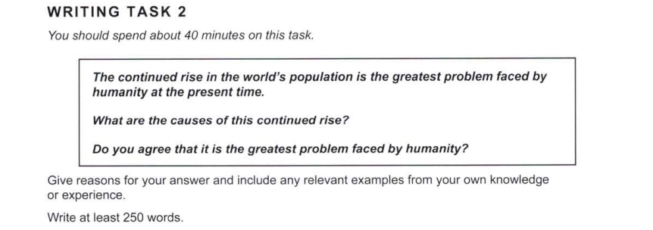

Essay Response:

Overpopulation is a widely-debated topic, with a plethora of opinions about its potential effects on human life in the future. In my opinion, this is not the biggest issue that humanity is facing. It is not an easy task to compare this to other prevalent issues, but to attempt to do so, we must explore its main causes. So, what are they?

The rapid rise in world population has been attributed to a number of reasons, ranging from religious to socio-economic, and are also related to the relatively recent strides made in the field of medicine. With new technological advancements and higher life expectancies, it is not uncommon for people to expect to live longer than their grandparents did. In some cases, families may have more children for financial reasons – either tax benefits, or hopes that their children will grow up to become the primary breadwinners for the family. Considering all of these reasons, does this pose a major risk to society as a whole?

It is hard to quantify this risk, since new research studies have shown that the world population is likely to plateau at around 11 or 12 billion by the end of this century. The problem of the birth rate being much higher than the death rate is one that is gradually fading away. However, it is still important to consider what a 11 billion figure would imply. Even if populations climb at a slower rate, we would have to consider factors such as food, housing and world peace when evaluating the issue of overpopulation. Thus, if humans can ensure that the growing population’s needs for food, shelter, and safety are met, then this would not be the ‘greatest problem’ that we face.

Finally, if we look at the concerns of climate change, the current trajectories do not seem favourable to preserving the planet’s biodiversity. One could argue that this would cause crop failure, making overpopulation a big issue. Though, the rising number of people is not the root issue here. Therefore, it would be reasonable to conclude that the sustained increase in world population is not the biggest problem we face, climate change is.